In C++ we have destructors to free the memory

We have to manually free the memory

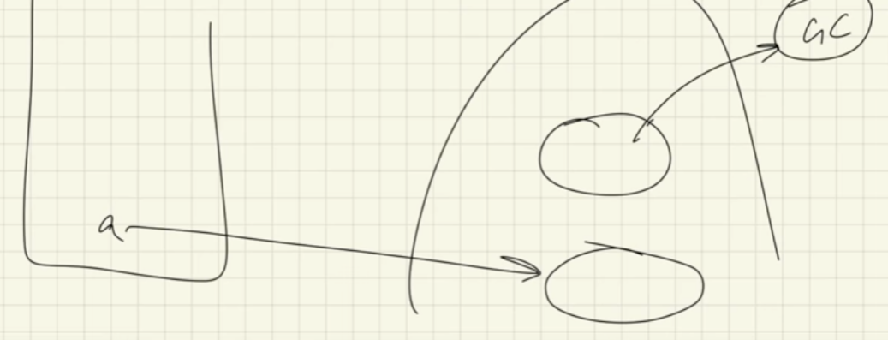

Initially the reference variable a in stack was pointing to the upper object in the heap

Later on it points to the lower one in heap

Now upper one do not have any reference variable pointing to it

So when garbage collector hits it the memory occupied by the upper object will be automaticly removed by the java

Here java automayicly destroys the objects for us

So we cannot manually destroy the object

But we can perform certain actions just after whenever the object is destroyed by java

Like we can display a message whenever the object is destroyed

It’s like

“ Hey Java I know you won’t allow me to destroy the object manually, so can you do this whenever you destroy the object ? “

We do this by finalize( ) method

